**16*2 LCD DISPLAY:**

LCD (Liquid Crystal Display) screen is an electronic display module and find a wide range of applications. A 16x2 LCD display is very basic module and is very commonly used in various devices and circuits. These modules are preferred over [seven segments](http://www.engineersgarage.com/content/seven-segment-display) and other multi segment [LED](http://www.engineersgarage.com/content/led)s. The reasons being: LCDs are economical; easily programmable; have no limitation of displaying special & even [custom characters](http://www.engineersgarage.com/microcontroller/8051projects/create-custom-characters-LCD-AT89C51) (unlike in seven segments), [animations](http://www.engineersgarage.com/microcontroller/8051projects/display-custom-animations-LCD-AT89C51) and so on.

A **16x2 LCD** means it can display 16 characters per line and there are 2 such lines. In this LCD each character is displayed in 5x7 pixel matrix. This LCD has two registers, namely, Command and Data.

The command register stores the command instructions given to the LCD. A command is an instruction given to LCD to do a predefined task like initializing it, clearing its screen, setting the cursor position, controlling display etc. The data register stores the data to be displayed on the LCD. The data is the ASCII value of the character to be displayed on the LCD. Click to learn more about internal structure of a [LCD](http://www.engineersgarage.com/insight/how-lcd-works).

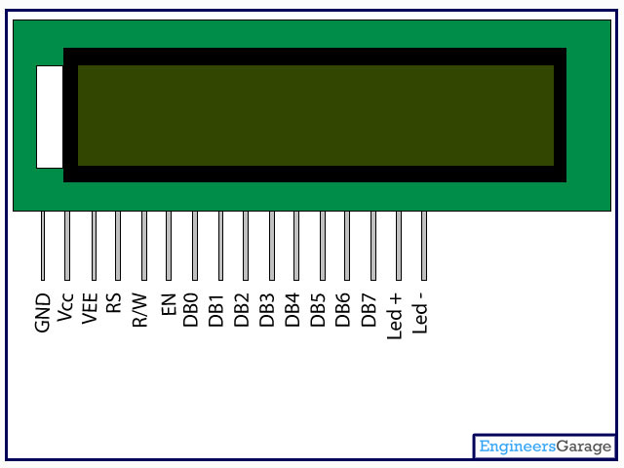

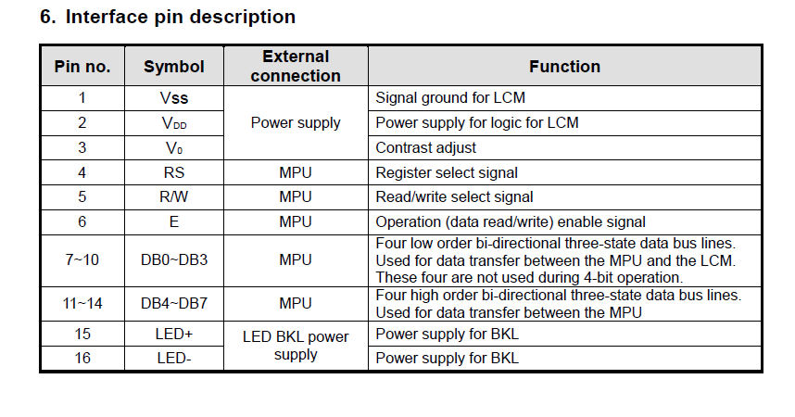

**V0 (Set Lcd contrast)**  
Set lcd contrast here. Best way is to use variable resistor such as potentiometer. Output of the potentiometer is connected to this pin. Rotate the potentiometer knob forward and backward to adjust the lcd contrast.   
  
**RS(Register select)**  
                                             Their are two registers in every lcd  
1 Command Register  
2 Data Register  
**Command Register**  
When we send commands to lcd these commands go to Command register and are processed their.  
Commands with their full description are given in the picture below.  
                                               When RS=0    Command Register is Selected.  
**Data Register**  
 When we send Data to lcd it goes to data register and is processed their.  
                                              When RS=1    Data Register is selected.  
 **RW(Read - Write)**  
                                             When RW=1  We want to read data from lcd.  
                                             When RW=0  We want to write to lcd.  
  
**EN(Enable signal)**  
When you select the register(Command and Data) and set RW(read -  write) now its time to execute the instruction. By instruction i mean the 8-bit data or 8-bit command present on Data lines of lcd.  
This requires an extra voltage push to execute the instruction and EN(enable) signal is used for this purpose. Usually we make it en=0 and when we want to exectue the instruction we make it high en=1 for some milli seconds. After this we again make it ground en=0.

Data which we send to our lcd can be any alphabet(small or big) , digit or ASCII character.  
  
**NOTE:** we can not send an integer,float,long,double type data to lcd because lcd is designed to display a character only. The 8 data pins on lcd carries only  ASCII 8-bit code of the character to lcd. How ever we can convert our data in character type array and send one by one our data to lcd. Data can be sent using lcd in 8-bit 0r 4-bit mode. If 4-bit mode is used, two nibbles of data (First high four bits and then low four bits) are sent to complete a full eight-bit transfer. 8-bit mode is best used when speed is required in an application and at least ten I/O pins are available. 4-bit mode requires a minimum of seven bits. In 4-bit mode, only the top 4 data pins (4-7) are used.

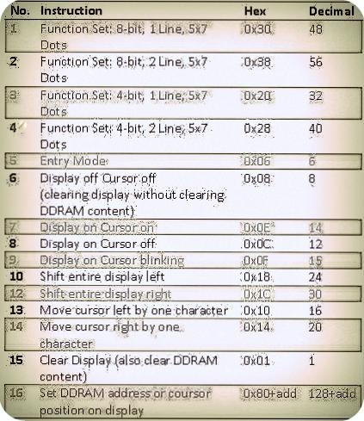

Command 0x30 means we are setting 8-bit mode lcd having 1 line and we are initializing it to be 5x7 character display.Now this 5x7 is some thing which every one should know what it stands for. usually the characters are displayed on lcd in 5x8 matrices form. where 5 is total number of coulombs and is number of rows.Thus the above 0x30 command initializes the lcd to display character in 5 coulombs and 7 rows the last row we usually leave for our cursor to move or blink etc.

The Character is displayed on lcd screen in 5x8 or 5x7 matrix. Where 5 represents number of coulombs and 7,8 represent number of rows. Maximum size of the matrix is 5x8. You can not display character greater then 5x8 dimension matrix. To display character greater than this dimension you have to switch to graphical lcds. To learn about graphical lcds here is a good tutorial [GRAPHICAL LCD WORKING AND PINOUT](http://www.microcontroller-project.com/128x64-graphical-lcd.html).

* The command 0x38 means we are setting 8-bit mode lcd having two lines and character shape between 5x7 matrix.
* The command 0x20 means we are setting 4-bit mode lcd having 1 line and character shape between 5x7 matrix.
* The command 0x28 means we are setting 4-bit mode lcd having 2 lines and character shape      between 5x7 matrix.
* The command 0x06 is entry mode it tells the lcd that we are going to use you'
* The command 0x08 dispalys cursor off and display off but with out clearing DDRAM contents.
* The command 0x0E displays cursor on and dispaly on.
* The command 0x0c dispaly on cursor off(displays cursor off but the text will appear on lcd)
* The command 0x0F dispaly on cursor blink(text will appear on screen and cursor will blink).
* The command 0x18 shift entire dispaly left(shift whole off the text on the particular line to its left ).
* The command 0x1C shift entire dispaly right(shift whole off the text on the particular line to its right).
* The command 0x10 Moves cursor one step left or move cursor on step a head to left when ever new character is displayed  on the screen.
* The command 0x14  Moves cursor one step right or move cursor on step a head to righ when ever new character is displayed on the screen.
* The command 0x01 clear all the contents of the DDRAM and also clear the lcd removes all the text from the screen.
* The command 0x80 initialize the cursor to the first position means first line first matrix(start point) now if we add 1 in 0x80+1=0x81 the cursor moves to second matrix.

16x1 lcd displays 16 characters only. The first will appear on 0x80 second 0x81 third 0x82 and so on until last, the 16 once on address 0x8F.